**Ideation Phase**

**Brainstorm & Idea Prioritization Template**

|  |  |
| --- | --- |
| Date | 28 June 2025 |
| Team ID |  |
| Project Name |  |
| Maximum Marks | 4 Marks |

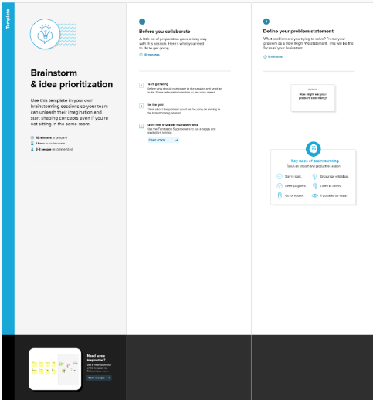 **1. Brainstorming & Problem Identification**

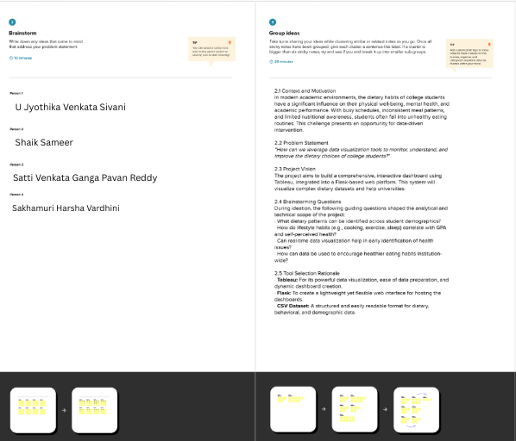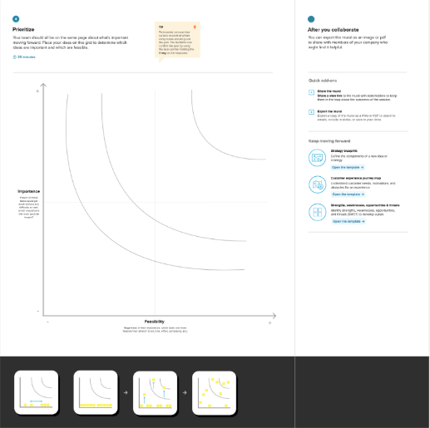

**1.1 Context and Motivation**

In modern academic environments, the dietary habits of college students have a significant influence on their physical well-being, mental health, and academic performance. With busy schedules, inconsistent meal patterns, and limited nutritional awareness, students often fall into unhealthy eating routines. This challenge presents an opportunity for data-driven intervention.

**1.2 Problem Statement**

*"How can we leverage data visualization tools to monitor, understand, and improve the dietary choices of college students?"*

**1.3 Project Vision**

The project aims to build a comprehensive, interactive dashboard using Tableau, integrated into a Flask-based web platform. This system will visualize complex dietary datasets and help universities:

* Monitor nutrition and health trends in real-time
* Identify unhealthy eating patterns or deficiencies
* Enable predictive planning and personalized interventions
* Support awareness programs and informed resource allocation

**1.4 Brainstorming Questions**

During ideation, the following guiding questions shaped the analytical and technical scope of the project:

* What dietary patterns can be identified across student demographics?
* How do lifestyle habits (e.g., cooking, exercise, sleep) correlate with GPA and self-perceived health?
* Can real-time data visualization help in early identification of health issues?
* How can data be used to encourage healthier eating habits institution-wide?

**1.5 Tool Selection Rationale**

* **Tableau:** For its powerful data visualization, ease of data preparation, and dynamic dashboard creation.
* **Flask:** To create a lightweight yet flexible web interface for hosting the dashboards.
* **CSV Dataset:** A structured and easily readable format for dietary, behavioral, and demographic data.